Template for Extended Abstracts
SUN Conference (Rome, 25.10.2017)

(max 2 pages)

This document presents the instructions needed to prepare the extended abstract to be included in the proceedings Conference. All abstracts should be written in English.
The abstract should be written in MS Word format in single-spaced in 12 point Calibri. Do not indent the text paragraphs. Please, briefly explain the aim and scope of your study, your materials and methods, and the main conclusions of the study. Max 2 figures/tabs can be placed in the abstract. Authors are requested to submit the extended abstract (max 2 pages) in electronic form (MS-Word) via email to the conference secretariat: info.sun@enea.it.

EXTENDED ABSTRACT HEADLINE
(CALIBRI, 14 FONT SIZE, BOLD, ALL CAPS, CENTERED)

Author’s Name and Surname¹, Author’s Name and Surname² (10 font size)
^{1, 2} Authors’ Department, Institute, COUNTRY.
(E-mail: firstauthorsname@aaaa.bbb, secondauthorsname@aaaa.bbb)
³ Author’s Department, Institute, COUNTRY.
(E-mail: thirdauthorsname@aaaa.bbb)
Please, indicate the author making the presentation with an asterisk (*)

Abstract (11 Font Size, bold, all caps, centered)- Abstract should be written in 150 words and with 10 font size, Calibri, justified, single line spacing. Objective, method and findings are summarized in this section.
Keywords: Keywords regarding the work are stated in this section. Said section should contain maximum 5 words that are written with 10 font size and seperated with commas.

- Introduction (Title Calıbrı, 12 font size, bold)
(Calibri, 11).

- Methods
(Calibri, 11).

  - Sub-headings
(Calibri, 11).

    - Tables, Images and Figures
(Calibri, 11).

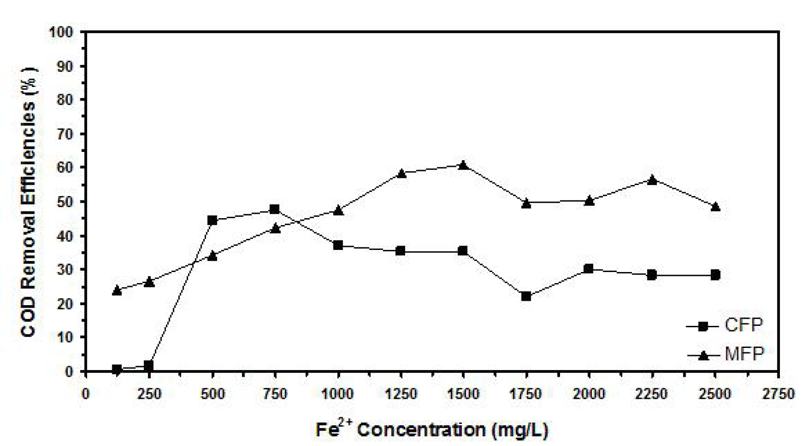
Figure 1. (Calibri 10)

Table 2. (calibri 10)
Source: (Calibri 10, italic)
- Results
(Calibri, 11).

- Discussion/Conclusion
(Calibri, 11).

References
(Calibri, 10).
- S. Park, G. Pitner, G. Giri, J. H. Koo, J. Park, K. Kim, H. Wang, R. Sinclair, H.-S. Philip Wong, Z. Bao (2015). Large-Area Assembly of Densely Aligned Single-Walled Carbon Nanotubes Using Solution Shearing and Their Application to Field-Effect Transistors. Advance Materials, 27, 2656-2662.

